<select ng-model='selectedCat' ng-options='cat.TITLE for cat in applicantList' **ng-click='groupingAnsw()'**  ></select>

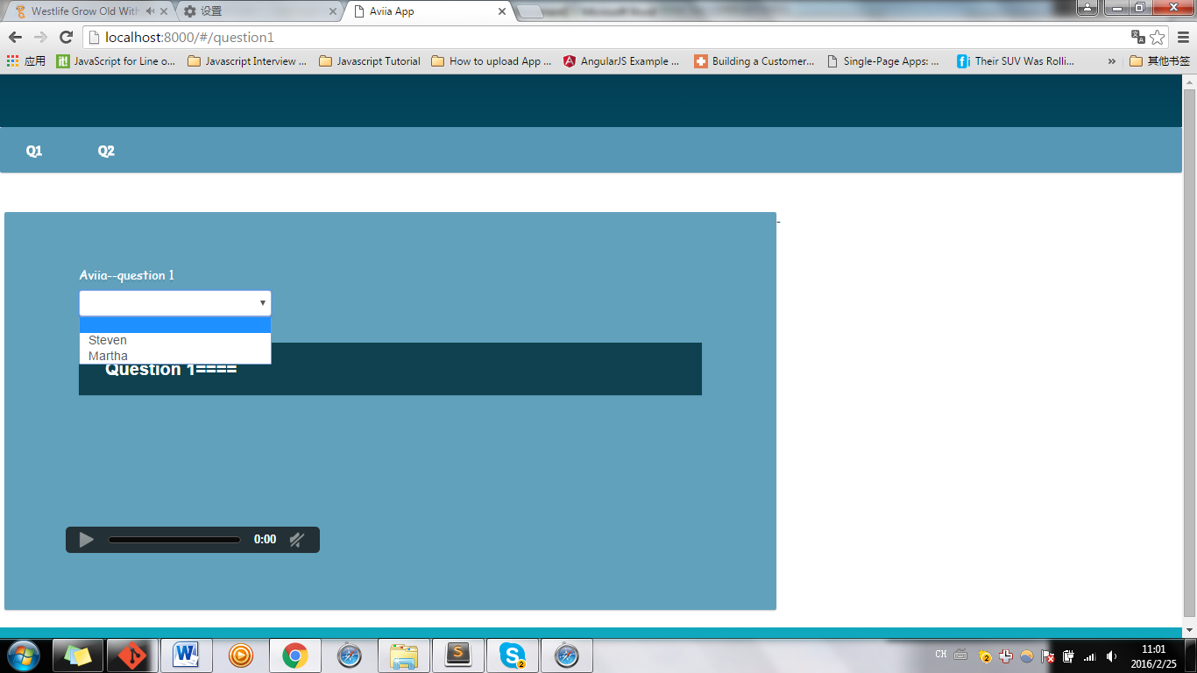

Ng-click not only for button, but for **option dropdown box,**

For **a hyper link** , see below

<label ng-repeat='cat in applicantList'>

<a href=""  **ng-click='groupingAnsw2(cat)'**>

<!-- <img ng-src="img/png 128/{{food.SHORTNAME}}.png"> -->

{{cat.TITLE}}

</label>

<label ng-repeat='cat in applicantList'>

// **WRONG:**

<label **ng-mode=’**  ’ **ng-repeat='cat in applicantList'**>

// ng-repeat can’t take any model out, as it only repeat!! While can pass a parameter to functions.

//====================

<a href=""  **ng-click='groupingAnsw2(cat)'**>

<!-- <img ng-src="img/png 128/{{food.SHORTNAME}}.png"> -->

{{cat.TITLE}}

</label>